Context: Learning and cognition

This resource is demarcated according to:

- Context Subheadings.
- Context Area of study (AOS) and the Context Learning Objectives (LOs)
  - These are addressed using the Content Learning Objectives.

Conceptual Analysis and Critical Thinking are both addressed at the Area of study (AOS) level.

Introduction:
Humans are born with a range of innate behaviours, but these behaviours only cover the most basic biological mechanisms and survival needs. Humans have highly developed cognitive abilities and can think about their own thinking (metacognition). This is why it is important to understand human cognition: what it is, how it can be described and
explained, how it develops and how reliable it is in various situations.

Humans and animals are capable of various forms of learning, some simpler, some more sophisticated. Conditioning is a simpler form of learning that can operate on the level of overt behaviours without requiring participation of cognitive processes. More sophisticated forms of learning rely on forming mental representations of reality (cognitive schemas). As social beings, people also learn from observing each other —this is known as social learning. Thinking and decision-making are probably the most complex cognitive processes that humans develop as a result of learning. Studying how people think about specific situations, and whether or not their decisions are accurate, presents great practical value. The dual processing model and the related idea of cognitive biases allow us to investigate these specific decision-making scenarios. However, there is also a variety of other cognitive processes, such as attention, perception, memory and language. Scientific investigation of a cognitive process implies creating a model of it and studying how it is affected by various factors (biological, cultural, environmental). If there is a valid model of a cognitive process, and knowledge of how it is affected, it is possible to design improvements.

Thinking and learning
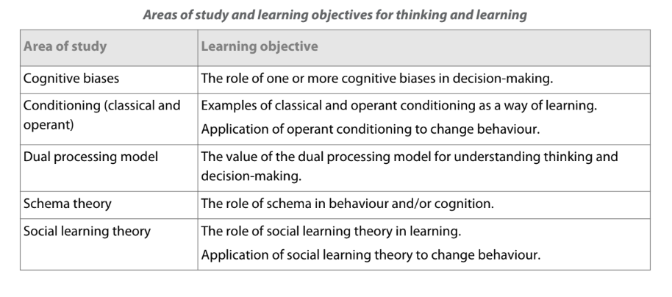

AOS: Cognitive biases
Context LO: The role of one or more cognitive biases in decision-making.

Cognitive biases are systematic errors in thinking that occur when people process and interpret information. These biases can distort decision-making by causing individuals to rely on shortcuts rather than logical reasoning. For example, anchoring bias leads people to base decisions too heavily on initial information, even if irrelevant. Confirmation bias causes individuals to seek or recall information that supports their existing beliefs while ignoring contradictions. These biases can result in poor or unfair decisions, especially in high-stakes settings like hiring, financial planning, or legal judgments. Understanding these biases can help individuals make more rational, balanced decisions by questioning their assumptions.

Content LO: Confirmation bias - The role of confirmation bias in decision-making.

Confirmation bias refers to the human tendency to search for, interpret, and remember information in a way that confirms pre-existing beliefs or expectations. This bias can affect decision-making in a variety of ways, particularly when people rely on mental shortcuts or schemas. These biases can cause people to misinterpret neutral information, ignore contradictory evidence, and remember details that align with what they already believe—ultimately distorting decision-making processes.
For example, Cohen (1981) investigated how pre-existing social schemas influence memory. Participants watched a video of a woman having dinner with her husband. Half were told she was a librarian, and the other half were told she was a waitress. The video included details consistent with both schemas—such as drinking wine or beer, liking classical music or country music—but participants later recalled more schema-consistent details. Those who believed she was a librarian were more likely to remember her liking books and classical music, while those who believed she was a waitress were more likely to recall her drinking beer and playing the guitar.
This study shows how confirmation bias operates at the level of attention and memory. Even when exposed to the same information, people notice and recall what fits their expectations, ignoring or forgetting contradictory details. In real-world settings, this can affect how individuals form impressions of others, make hiring decisions, or evaluate evidence in legal and medical contexts.
Confirmation bias demonstrates how schemas can guide attention and recall in ways that reinforce prior beliefs, showing the importance of developing strategies to actively question assumptions and seek out disconfirming evidence when making decisions.

Content LO: Anchoring bias - The role of anchoring bias in decision-making.

Anchoring bias refers to the human tendency to rely too heavily on the first piece of information (the ‘anchor’) encountered when making decisions. This initial information sets a reference point, and subsequent judgments are made by adjusting away from that anchor, often insufficiently. This cognitive bias affects various types of decision-making, including financial, sociocultural and personal decisions. For example, Tversky and Kahneman’s (1974) asked participants to estimate the percentage of African countries in the United Nations after witnessing a random number generated by a ‘wheel of fortune’. The key manipulation was that the wheel produced either a high number (65) or a low number (10) as the starting point or ‘anchor’. Despite the anchor’s irrelevance to the actual question, participants’ estimates were significantly influenced by it: those who saw the higher number gave higher estimates, and those who saw the lower number gave lower estimates.

This study shows how an anchoring bias using unrelated initial information can skew subsequent judgments and decisions. Even when individuals are aware that the anchor should not influence their estimation (by spinning the wheel) the initial number significantly impacts their final judgment. Further research has shown that initial salary offers, for example, have a strong anchoring effect on the final agreed-upon salary, illustrating the influence of anchoring bias in practical settings.

Anchoring bias demonstrates how initial information, even if arbitrary, can significantly influence subsequent judgments and decisions, emphasizing the need for awareness and strategies to mitigate its effects in critical decision-making processes.

AOS: Conceptual Analysis

For this Area of Study conceptual analysis is in the form of:

Bias
The concept of bias applies because cognitive biases represent systematic deviations from rational thinking that shape how individuals interpret and respond to information. Anchoring and confirmation bias distort judgment by causing individuals to over-rely on initial information or selectively attend to evidence that supports their pre-existing beliefs. These mental shortcuts often occur unconsciously and affect decisions in everyday and high-stakes contexts, such as legal judgments or hiring. Understanding bias highlights how even well-intentioned decisions may be influenced by flawed reasoning, emphasizing the importance of developing strategies to detect and reduce such distortions.
Causality
The concept of causality applies because cognitive biases are thought to influence behavior, but their relationship to outcomes is complex and often indirect. For example, confirmation bias may appear to cause poor decision-making, but it can also be the result of motivational or emotional factors, such as the desire to maintain a coherent worldview. Similarly, anchoring may not always determine final decisions but may simply influence the range of considered options. Bidirectional ambiguity makes it difficult to isolate cognitive biases as sole causes. Experimental methods, like those used by Tversky and Kahneman, help clarify causal relationships, but real-world decisions often involve multiple overlapping influences.
Perspective
The concept of perspective applies because cognitive biases can be understood through different psychological approaches. From a cognitive perspective, biases are heuristics—mental shortcuts evolved to simplify decision-making under uncertainty. A social perspective highlights how group norms and stereotypes influence biases like confirmation bias, especially in social judgments. From an evolutionary viewpoint, biases may have once served adaptive functions, helping humans make rapid decisions with limited information. These varied perspectives show that biases are not simply flaws but context-dependent tools that sometimes help and sometimes hinder rational thought.

AOS: Critical Analysis
For this Area of Study critical analysis is in the form of:

Alternative explanations
While cognitive biases offer strong explanations for irrational decision-making, alternative perspectives highlight additional influences. For example, dual process theory suggests that biases may arise from the use of intuitive, fast-thinking (System 1) rather than reflective, slow-thinking (System 2). Emotional states, time pressure, and cognitive load can increase reliance on biased heuristics. Sociocultural factors also play a role: confirmation bias may be reinforced in echo chambers or groupthink settings, and anchoring may reflect social norms or culturally learned expectations. Additionally, some decisions that appear biased may actually be adaptive under real-world conditions, suggesting that not all deviations from rationality are dysfunctional. Therefore, integrating cognitive, emotional, and contextual explanations gives a more complete understanding of decision-making.

Task
By the end of this Area of Study you should be able to:

Explain: Confirmation bias - The role of confirmation bias in decision-making; Anchoring bias - The role of anchoring bias in decision-making.

Evaluate/discuss the role of one or more cognitive biases in decision-making.

Example Questions for this Area of Study

Paper 1

Section A
Describe the role of anchoring bias in decision-making (4)

Section B
A teacher believes that boys are better at math than girls. When marking assignments, she pays more attention to errors in the girls’ work and overlooks similar mistakes in the boys’ work. She later concludes that her belief was correct.
With reference to this situation, explain how confirmation bias can be used to understand decision-making. (6)

Section C
Discuss the role of one or more cognitive biases in decision-making. Include the concept of perspective in your response. (15)

AOS: Conditioning (classical and operant)
Context LO: Examples of classical and operant conditioning as a way of learning.

Classical and operant conditioning are two key learning processes that help explain behavior. In classical conditioning, a neutral stimulus becomes associated with an unconditioned stimulus, triggering a conditioned response—such as trauma-related cues causing fear in PTSD. For example, loud noises may become linked with traumatic memories, leading to distress in safe settings. In operant conditioning, behaviors are shaped by consequences. PTSD avoidance behaviors are negatively reinforced when avoiding trauma triggers reduces anxiety, making the behavior more likely. Both conditioning processes can maintain PTSD symptoms, which is why exposure-based therapies aim to weaken these learned responses through safe, repeated exposure.

This relates to learning and cognition because: both classical and operant conditioning demonstrate how external stimuli and consequences shape behavior without requiring conscious thought. This shows that learning can occur even in the absence of awareness or reasoning, distinguishing conditioning from more complex cognitive processes like decision-making or problem-solving. At the same time, these conditioned behaviors can influence cognitive processes—such as perception, attention, and memory—by biasing what individuals notice and how they interpret their environment. For example, a person with PTSD may attend more to trauma-related cues or interpret neutral stimuli as threatening due to prior conditioning. Therefore, understanding conditioning provides insight into the interaction between learned behaviors and cognitive functions, highlighting how automatic responses can become embedded in thought patterns and influence future behavior and emotional regulation.

PTSD is used as an example because you will also study it in Health and well-being.

Content LO: Classical conditioning - The process of classical conditioning and its role in behaviour.

Classical conditioning is a learning process where a neutral stimulus becomes associated with an unconditioned stimulus, triggering a conditioned response. In PTSD, a traumatic event (unconditioned stimulus) elicits intense fear (unconditioned response). Neutral cues present during the trauma (e.g., sounds, smells) become conditioned stimuli, later provoking fear responses even in safe environments. This explains PTSD symptoms like flashbacks and hypervigilance, as previously neutral stimuli trigger distress.

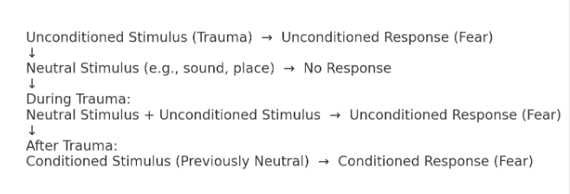
The persistence of these associations contributes to maladaptive fear responses, making extinction therapy (e.g., exposure therapy) particularly important for treatment by weakening the conditioned fear response through repeated safe exposure to trauma-related cues. For example, a soldier who experienced a bomb explosion (unconditioned stimulus) may later feel intense fear (conditioned response) whenever they hear loud noises like fireworks (conditioned stimulus), even in a safe environment. Therefore, therapy would involve gradual and repeated exposure to loud noises in a controlled, safe environment to weaken the fear response, helping the individual re-learn that these sounds are not dangerous.

Content LO: Operant conditioning - The process of operant conditioning and its role in behaviour.

Operant conditioning is a learning process where behaviors are shaped by consequences. In PTSD, avoidance behaviors are reinforced through negative reinforcement. After trauma, a person may avoid trauma-related situations (behavior), reducing anxiety (removal of distress), reinforcing avoidance. This prevents emotional processing and maintains PTSD symptoms. For instance, a veteran avoiding crowds due to a past explosion may experience immediate relief, strengthening avoidance.

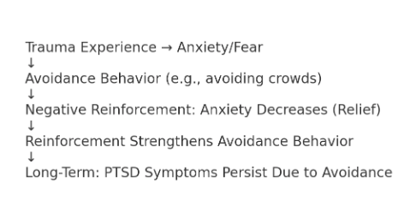
This maladaptive cycle makes exposure-based therapies particularly important, as they reduce avoidance behaviors and promote healthier coping mechanisms by gradually reintroducing trauma-related stimuli without negative consequences, weakening the reinforcement of avoidance behaviors. For example, a veteran who avoids crowded places due to trauma may feel temporary relief, reinforcing avoidance. Therefore, therapy would involve gradual exposure to crowds in a controlled, safe manner, helping them relearn that such environments are not dangerous.

Context LO: Application of operant conditioning to change behaviour.
Operant conditioning can be effectively applied to change behaviour by systematically altering the consequences that follow specific actions. In PTSD, avoidance behaviours are often maintained through negative reinforcement: individuals avoid trauma-related stimuli (e.g., crowds, loud noises), which reduces their anxiety in the short term. This relief strengthens the likelihood of continued avoidance, preventing emotional processing and reinforcing the disorder. For example, a veteran who avoids crowded public spaces due to past trauma may feel immediate comfort, reinforcing the idea that avoidance keeps them safe. However, this coping strategy can limit daily functioning and social engagement.
To interrupt this cycle, therapists use exposure-based interventions grounded in operant conditioning principles. By gradually and safely exposing individuals to trauma-related cues without negative outcomes, the avoidance behaviour is no longer reinforced. Over time, this weakens the association between the trigger and the distress response. Additionally, positive reinforcement can be introduced to reward engagement in healthy behaviours—such as attending therapy sessions or engaging in social activities—through praise, tangible rewards, or self-monitoring systems. This helps to build new, adaptive behavioural patterns.
By modifying both the potential causes and consequences of behaviour, operant conditioning provides a powerful framework for reducing maladaptive responses and encouraging recovery in individuals experiencing PTSD or other anxiety-related disorders.

AOS: Conceptual Analysis

For this Area of Study conceptual analysis is in the form of:
Causality
The concept of causality applies because classical and operant conditioning offer clear mechanisms for how behaviours are learned and maintained. In PTSD, classical conditioning explains how neutral stimuli become associated with trauma, leading to learned fear responses. Operant conditioning explains how avoidance behaviours are negatively reinforced, increasing their likelihood over time. These causal relationships provide a framework for understanding the development of maladaptive behaviours. However, causality becomes more complex in real-world settings where multiple factors interact. While exposure therapy demonstrates how learned behaviours can be unlearned through extinction, it is difficult to isolate conditioning as the sole cause without considering biological and cognitive influences.
Perspective
The concept of perspective applies because learning can be interpreted through multiple psychological lenses. From a behavioural perspective, PTSD symptoms are learned through environmental interactions—fear through classical conditioning and avoidance through operant reinforcement. This perspective supports practical interventions like exposure therapy. However, cognitive perspectives highlight the role of memory, attention, and interpretation in maintaining fear responses, suggesting that learning involves both associations and beliefs. A multi-perspective view enriches our understanding of how behaviours are acquired and changed, ensuring more effective and individualised treatment approaches.
Change
The concept of change applies because conditioning models do not just explain how behaviours are learned but also how they can be unlearned. Exposure-based therapies rely on classical conditioning principles of extinction to reduce fear responses, and operant techniques reduce avoidance by removing reinforcement. These approaches demonstrate that even deeply ingrained responses can be modified through targeted learning experiences. However, change can be slow or incomplete if associations are strong or if other psychological processes—like catastrophic thinking—interfere with learning. Understanding how change occurs through conditioning helps psychologists design step-by-step, evidence-based interventions to support behaviour modification in individuals with PTSD.

AOS: Critical Analysis
For this Area of Study critical analysis is in the form of:

Alternative explanations
While classical and operant conditioning effectively explain how behaviours such as fear responses and avoidance are learned and maintained, alternative explanations suggest that these learning processes do not operate in isolation. Cognitive theories argue that PTSD symptoms are also influenced by maladaptive thought patterns—such as catastrophizing or attentional biases—which affect how stimuli are interpreted. For example, two individuals may experience the same traumatic cue, but only one may develop a conditioned fear response based on how they appraise the threat.
Biological explanations also provide alternative accounts, highlighting the role of neurochemical imbalances (e.g., serotonin dysregulation) and heightened amygdala activity in the development and persistence of PTSD. These biological vulnerabilities may influence how easily certain behaviours are learned or how resistant they are to unlearning.
Furthermore, not all individuals respond equally to exposure therapy, suggesting that conditioning alone cannot account for all behavioural change. Personal motivation, cognitive flexibility, and social support may moderate the success of unlearning. Therefore, while conditioning offers a strong behavioural framework, integrating cognitive, biological, and contextual explanations provides a more comprehensive understanding of how behaviours are both acquired and altered.

Task
By the end of this Area of Study you should be able to:

Explain: Classical conditioning - The process of classical conditioning and its role in behaviour; Operant conditioning - The process of operant conditioning and its role in behaviour.

Evaluate/discuss examples of classical and operant conditioning as a way of learning.
Evaluate/discuss application of operant conditioning to change behaviour.

Example Questions for this Area of Study

Paper 1

Section A
Explain the process of operant conditioning and its role in behaviour (4)

Section B
A child is bitten by a dog while walking home from school. Afterwards, the child feels intense fear whenever they see any dog, even friendly ones. To cope, the child starts avoiding routes where dogs are likely to be. Each time the child avoids those areas, they feel less anxious.
With reference to this situation, explain how classical and/or operant conditioning can be used to understand behaviour. (6)
Section C
Discuss the application of operant conditioning to change behaviour.(15)

