IBDP Economics - Introduction

This booklet introduces the subject of Economics and some of its underlying principles, concepts (big ideas) and assumptions that will occur throughout the course. There are 6 parts to this document:
- Economics is a study of human behaviour
- The basic economic problem.
- Opportunity cost
- The Production Possibility Curve
- Sustainability
- The Circular Flow Model
- The market

Economics – a study of human behaviour
Economics is the study of how individual people, businesses, and societies make choices about allocating limited resources to satisfy their wants and needs, often assuming that people act with rational behavior, meaning they make decisions that maximize their benefits while minimizing costs. It analyzes human behavior by examining how people weigh costs and benefits and respond to incentives. For example, economics can explain why people smoke cigarettes despite health risks by considering how they balance immediate pleasure against future health costs. Similarly, when buying fashion clothes, consumers make rational choices based on income, trends, and the perceived value of the product. By understanding how people act rationally (or irrationally) in these decisions, economics provides insight into how resources are prioritized and choices are made.
The basic economic problem
The basic economic problem arises from the fact that humans have unlimited wants and needs, but there are only finite resources available to satisfy them. This creates scarcity, forcing individuals and societies to make choices about how to allocate limited resources effectively. For example, a government might have a limited budget and must choose between investing in healthcare or education. These trade-offs are central to economics, as decisions must be made on how to use scarce resources to meet the most pressing needs and wants.
Opportunity cost is the value of the next best alternative foregone, i.e. that must be given up when making a choice. It arises from scarcity, which is the basic economic problem where resources are limited, but wants and needs are unlimited. Because of this, individuals, firms, and governments must make decisions on how to allocate resources efficiently, leading to trade-offs between different options.
At a personal level, if you decide to spend money on a new laptop, the opportunity cost might be a vacation you can no longer afford because of that purchase. For a firm, if it chooses to invest in new machinery, the opportunity cost might be expanding into a new market or hiring more employees with the same funds. At the government level, if a country allocates more resources to defense spending, the opportunity cost might be less investment in healthcare or education, which could impact the overall well-being of its citizens.
The Production Possibility Curve (PPC), or Production Possibility Frontier (PPF), is a model in economics that illustrates the different combinations of two goods or services that an economy can produce with its available resources and technology. It visually represents scarcity, trade-offs, and opportunity costs in resource allocation.
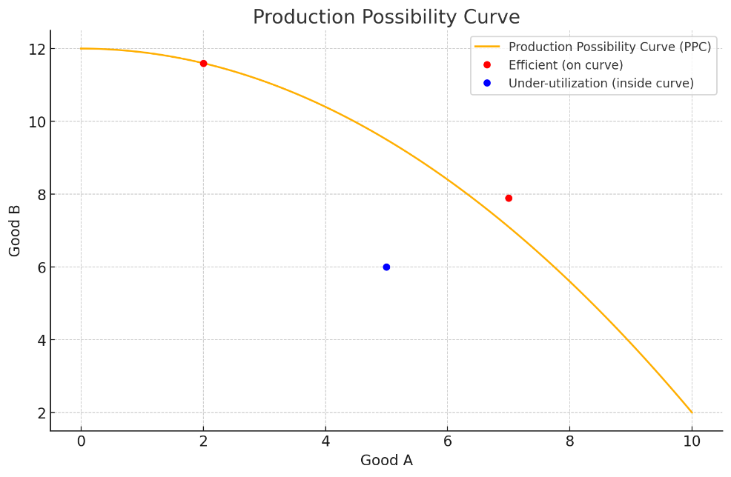
Figure 1: The Production Possibility Curve illustrating Opportunity Cost.

The trade-offs between producing two different goods, A and B, are illustrated along the curve, where an increase in the production of one good requires a decrease in the other. Maximum use of resources is represented by points on the curve, where all resources are fully and efficiently utilized. Under-utilization of resources is shown by points inside the curve, indicating that some resources (labor, capital, etc.) are not being fully used, leading to inefficient production. Opportunity costs are illustrated by the trade-offs along the curve—producing more of one good requires producing less of another, as resources are reallocated between goods.
The underlying assumption of the PPC is that the economy is operating with fixed resources and technology. An outward shift of the curve represents economic growth—an increase in the economy’s capacity to produce more of both goods due to factors like improved technology, more resources, or better efficiency. An inward shift indicates a contraction of the economy, where fewer goods can be produced due to a decrease in resources, such as during a recession or natural disaster.
Sustainability refers to the ability to meet the needs of the present without compromising the ability of future generations to meet their own needs. It involves managing resources in a way that balances economic, environmental, and social factors to ensure long-term viability and health of ecosystems.
The sustainable use of natural resources means using resources at a rate that allows them to regenerate and continue to provide benefits over time, avoiding the depletion or permanent damage of these resources.
Over-exploitation occurs when natural resources are used at a rate faster than they can regenerate, leading to depletion or degradation. For example, overfishing in the North Sea has led to a significant decline in fish stocks, threatening marine ecosystems and the fishing industry. If not managed sustainably, these fish populations may collapse, affecting biodiversity and food supply.
Under-exploitation is when resources are not used to their full potential, which can lead to missed opportunities for economic and social benefits. For instance, forests in Montenegro could provide more timber sustainably if properly managed, but lack of infrastructure or policy might lead to under-use, limiting economic growth without harming the environment.
In the Middle East, oil is a finite resource, and the over-exploitation of oil reserves poses a sustainability challenge. Extracting oil at unsustainable rates can lead to depletion, environmental damage, and economic instability in oil-dependent nations when reserves run out or prices fluctuate.
Many natural resources do not have property rights and are called common access resources, e.g. the wind, the atmosphere, the open ocean (the ocean areas that are outside countries; exclusive economic zones), and fish stocks in the open ocean. There is no incentive for people to use these common access resources sustainably and there is a tendency to use them ‘quickly before someone else does’. Over-exploitation or depletion of common access resources can become the source of inter-country disputes.
The Circular Flow model
A model is a simplified representation or abstraction of reality designed to explain and predict economic phenomena. Models are used to analyze how different variables interact and to understand complex economic systems. They focus on essential factors while ignoring less relevant details, allowing economists to study economics relationships such as supply and demand, inflation, or economic growth in a manageable way.
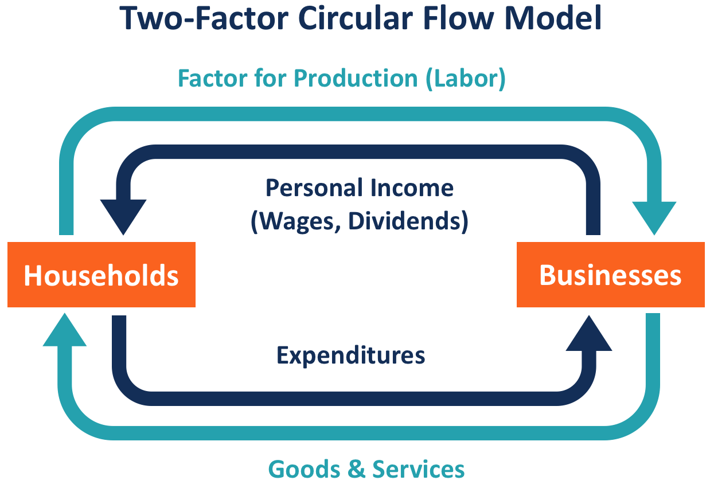
Figure 2: The 2-sector Circular Flow Model - a simple representation of an economy.
Source: Circular Flow Model - Overview, How It Works, & Implications (corporatefinanceinstitute.com)

Households provide the factors of production (land, labour, capital and enterprise) to firms and in return, firms provide goods and services to households. This is called the real flow in the economy. The money flow, flows in the opposite direction. Firms pay to households the factor rewards (rent, wages, interest and profit/dividends) and households pay payments for goods and services to firms. (A dividend is a shareholder’s share of a firm’s profit.)
The factors of production are land (all natural resources, not just land but water, air, coal, oil…), labour (all human resources, e.g. bus driving, novel writing, baking…), capital (man-made resources, e.g. factory machinery, computers, ships…) and enterprise (the risk of doing business, which some people include in Labour). The factor rewards or factor incomes are rent, wages, interest and profit/dividends.
This basic, two-sector circular flow model illustrates how resources flow between households and firms, with households supplying inputs and receiving goods and services in return. (Remember, it’s not supposed to be an exact replication; it’s a model, a simple representation…) A more advanced or complex (5-sector) circular flow model expands on the basic 2-sector model (households and firms) to include additional sectors that reflect the full range of economic activity. These sectors are the foreign sector, the financial sector, and the government sector. The interaction between these sectors creates a comprehensive picture of how money, goods, services, and resources move through the economy.
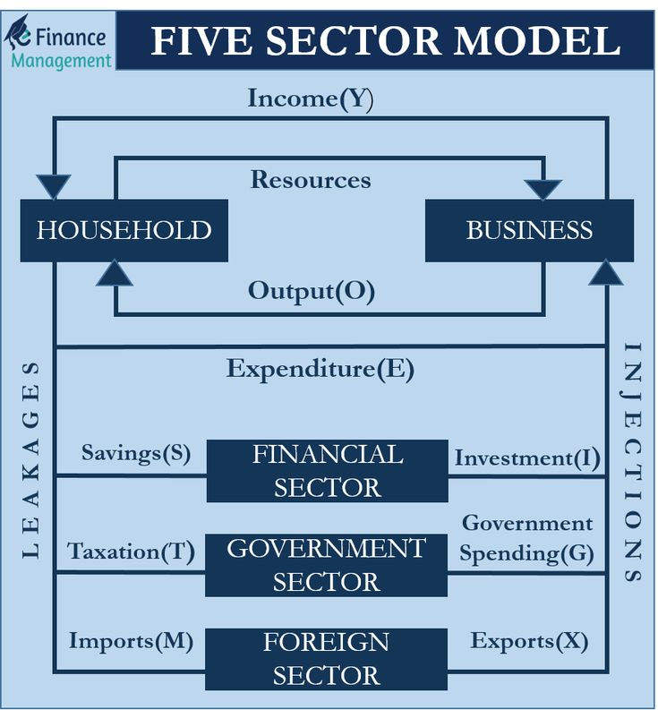
Figure 3: The 5-sector (complex) Circular Flow Model - a simplified representation of an economy.
Source: Five Sector Model – Meaning, Relationship, and Diagram (pinterest.com)

1. Households:
- Provide labor and other factors of production (land, labour, capital) to firms/business in exchange for wages, rent, and interest (we prefer to use the term ‘firms’ because not all firms are ‘businesses’.
- Consume goods and services produced by firms.
- Pay taxes to the government.
- Save money in financial institutions (some say banks, but there are more financial institutions than banks), which provide these savings as capital to firms for investment. (In Economics, the word ;investment’ does not mean savings; it means ‘buying capital goods’ – capital goods are those that make other goods, e.g. factories, factory equipment, delivery vans, doughnut-making machines etc.)
2. Businesses (Firms):
- Produce goods and services using the factors of production provided by households.
- Sell goods and services to both households and the government.
- Pay wages and other incomes to households.
- Borrow from financial markets for investment (buying capital goods).
- Pay taxes to the government.
3. Government Sector:
- Collects taxes from both households and firms.
- Provides public goods and services, such as education, healthcare, and infrastructure, that benefit both households and firms.
- Makes transfer payments (such as welfare, subsidies, or pensions) to households.
- Buys goods and services from firms to carry out government activities.
4. Financial Sector:
- Receives savings from households and firms.
- Provides loans to households, firms, and the government for consumption and investment.
- Facilitates the flow of money through interest rates, investments, and deposits.
- Invests in both domestic and international markets to earn returns.
5. Foreign Sector:
- Exports goods and services produced by domestic firms to other countries, earning revenue.
- Imports goods and services from foreign firms, which households and firms consume domestically.
- Foreign investment flows between countries, with firms borrowing or investing internationally.
- Balance of trade (exports minus imports) affects the flow of money between the domestic and international sectors.
Flows in the Complex Circular Flow Model:
- Real flows, i.e. goods and services flow between households, firms, and the government.
- Money flows, i.e. payments (wages, taxes, loans, profits, etc.) between households, firms, the government, and the financial sector.
- International trade creates inflows and outflows of money and goods (and services), as countries exchange products and services.
- Financial markets facilitate investment, saving, and borrowing, ensuring that the economy has the capital needed for growth.
How the model works:
- Households receive income from firms and governments, save some of it in financial institutions, and spend the rest on goods and services produced by firms.
- Firms use money borrowed from the financial sector to invest in production, and they sell goods to households, the government, and international markets.
- The government collects taxes, buys goods from firms, and provides public services to both households and firms.
- The international sector allows for trade, with imports flowing into the country and exports generating income for domestic firms.
- Note that this model represents one of many economies that interact and are interdependent, through their Foreign Sectors. We could create a massive model of all economies, but that would make our heads hurt, so we don’t.
The market
A market is any situation in which buyers and sellers interact. Buyers (consumers) aim to satisfy their wants and needs by buying goods and services. Sellers (producers/firms) aim to generate a profit by selling goods and services. The market can be represented by the Supply and Demand Graph / Model.
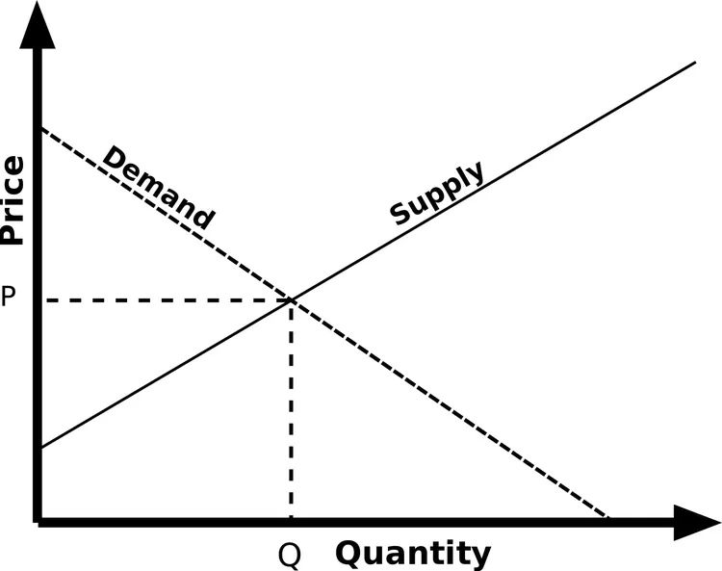
Figure 4: The supply and demand graph / model showing the simultaneous law of demand and law of supply.
Source: Illustrated Guide to the Supply and Demand Equilibrium (thoughtco.com)

Consumers behave according to the law of demand: as the price of a good increases, the quantity demanded decreases. At the same time (simultaneously), producers behave according to the law of supply: as the price of a good increases, the quantity supplied increases. A free market settles or clears at equilibrium, i.e. when the quantity demanded equals the quantity supplied. This model assumes all people behave rationally, meaning consumers aim to maximize their satisfaction derived from the consumption of goods and services and producers aim to maximize their profits, derived from selling goods and services.

Introductory Economics
150 Multiple Choice Tests
by Jamie Kurow
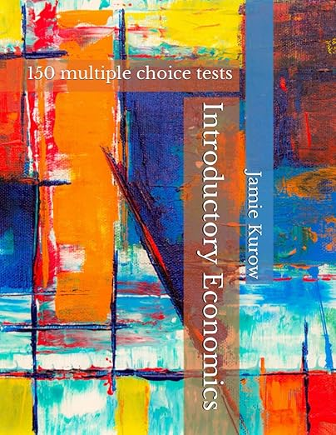
Introductory Economics - 150 multiple choice tests is designed to enhance students’ understanding of key concepts in introductory economics through a series of carefully curated multiple-choice tests. Although the tests are primarily written for use by teachers/instructors, this book is also suitable for any self-taught student or any student who simply wants to brush up on topics before important exams. These tests are suitable for all introductory Economics courses including International Baccalaureate (SL and HL), AS and A-Level, Advanced Placement and most first-year college/university courses. The tests cover microeconomics, macroeconomics, international/global economics, and development economics. Use these tests as simple and quick formative assessments. These tests will help gauge students’ comprehension levels, identify areas of weakness and so inform and guide further teaching and learning. They can also be used to encourage active engagement and reflection throughout the learning process.
Amazon link

Multiple choice test
Circle the letter associated with the best answer.

1. Economics is primarily concerned with how individuals, businesses, and societies:
a) Make decisions about unlimited resources.
b) Make choices about allocating limited resources.
c) Produce unlimited goods.
d) Avoid making choices.

2. Rational behavior in economics refers to people making decisions that:
a) Maximize costs while minimizing benefits.
b) Maximize benefits while minimizing costs.
c) Only focus on short-term gains.
d) Are influenced only by emotions.

3. One key assumption in economics is that people act:
a) Randomly.
b) With no concern for cost.
c) Irrationally.
d) Rationally, by weighing costs and benefits.

4. Scarcity in economics refers to:
a) The availability of unlimited resources.
b) The limited availability of resources to meet unlimited wants and needs.
c) The oversupply of goods.
d) The elimination of choices.

5. The basic economic problem arises because:
a) Resources are infinite, but wants are limited.
b) Resources are limited, but wants are unlimited.
c) People are always satisfied with their choices.
d) There is no need to make trade-offs.

6. A government facing scarcity must make decisions about:
a) How to eliminate trade-offs.
b) Which resources to leave unused.
c) How to allocate limited resources effectively.
d) How to ignore opportunity costs.

7. Opportunity cost is defined as:
a) The benefit received from making a choice.
b) The next best alternative foregone when a decision is made.
c) The total cost of all possible options.
d) The amount of money spent on a decision.

8. Opportunity cost arises from:
a) Having unlimited resources.
b) The existence of scarcity.
c) Decisions made without considering costs.
d) Having too many choices.

9. When a person decides to buy a new laptop instead of going on vacation, the opportunity cost is:
a) The money saved from not going on vacation.
b) The laptop purchased.
c) The utility or satisfaction from vacation they gave up.
d) The cost of the laptop.

10. For a firm, investing in new machinery might have an opportunity cost of:
a) Lower wages for employees.
b) Expanding into a new market or hiring more employees.
c) A decrease in product quality.
d) Improved efficiency.

11. A government allocating more resources to defense spending could face the opportunity cost of:
a) Investing in healthcare or education.
b) Increasing wages.
c) Eliminating trade-offs.
d) Increasing exports.

12. In economics, trade-offs refer to:
a) Decisions that involve no costs.
b) Choices made without any consequences.
c) Sacrificing one good or service for another due to limited resources.
d) Producing goods with unlimited resources.

13. Economics can explain why people smoke cigarettes despite health risks by:
a) Ignoring the costs involved.
b) Understanding how they balance immediate pleasure against future health costs.
c) Focusing only on their emotions.
d) Studying government policies.

14. When consumers buy fashion clothes, their decisions are based on:
a) Random choices.
b) Income, trends, and perceived value.
c) Emotional reactions alone.
d) Only government regulations.

15. Understanding opportunity costs helps individuals and societies:
a) Avoid making difficult decisions.
b) Allocate resources efficiently and make informed trade-offs.
c) Spend all resources without concern.
d) Always make the best decision without trade-offs.

16. The Production Possibility Curve (PPC) illustrates:
a) The demand for two goods in the economy.
b) The trade-offs between producing two different goods with limited resources.
c) The maximum price for goods in the economy.
d) The allocation of resources without scarcity.

17. Points on the PPC curve represent:
a) Under-utilization of resources.
b) Maximum and efficient use of resources.
c) An inward shift in the economy.
d) Unemployment in the economy.

18. Under-utilization of resources on a PPC is shown by:
a) Points outside the curve.
b) Points on the curve.
c) Points inside the curve.
d) Shifts in the curve.

19. Opportunity cost is illustrated on the PPC by:
a) Increasing the production of both goods simultaneously.
b) Producing more of one good and less of another.
c) Reducing the production of both goods.
d) Increasing resources without trade-offs.

20. An outward shift of the PPC represents:
a) Economic contraction.
b) A decrease in resources.
c) Economic growth due to more resources or improved technology.
d) A lack of resources and inefficiency.

21. What does an inward shift of the PPC indicate?
a) Economic growth.
b) An increase in the production of both goods.
c) A contraction of the economy due to decreased resources or a natural disaster.
d) A better use of technology.

22. Sustainability refers to:
a) Using all available resources immediately.
b) Meeting present needs without compromising future generations' ability to meet their own needs.
c) Over-exploitation of resources for short-term gains.
d) Limiting resource use to reduce economic growth.

23. Over-exploitation of natural resources occurs when:
a) Resources regenerate faster than they are used.
b) Resources are used at a rate faster than they can regenerate.
c) Resources are left unused, leading to inefficiency.
d) There is no impact on the environment.

24. Under-exploitation of resources can lead to:
a) Depletion of resources.
b) Economic instability.
c) Missed opportunities for economic and social benefits.
d) Decreased biodiversity.

25. Common access resources are:
a) Natural resources with well-defined property rights.
b) Resources that are privately owned and controlled.
c) Resources like the wind, atmosphere, and open ocean that are not privately owned and often over-exploited.
d) Resources that are never subject to depletion or environmental disputes.

26. The circular flow model is used in economics to:
a) Represent only one sector of the economy.
b) Simplify and explain economic interactions between different sectors.
c) Replace all economic data with diagrams.
d) Focus only on consumer behavior.

27. In the 2-sector circular flow model, households provide:
a) Goods and services to the government.
b) Factors of production (land, labor, capital) to firms.
c) Loans to financial institutions.
d) Only capital goods to firms.

28. The real flow in the 2-sector circular flow model refers to:
a) The movement of money between households and firms.
b) The exchange of goods and services between firms and households.
c) Tax payments between households and the government.
d) Financial investments made by households.

29. The money flow in the circular flow model moves in the opposite direction to:
a) The government sector.
b) The real flow of goods and services.
c) Foreign trade.
d) Financial markets.
30. The factor rewards in the circular flow model include:
a) Dividends, salaries, and government subsidies.
b) Rent, wages, interest, and profit/dividends.
c) Government taxes and savings.
d) Imports and exports.

31. In the more complex circular flow model (5-sector model), the additional sectors are:
a) Foreign sector, financial sector, and government sector.
b) Technology sector, education sector, and government sector.
c) Labor sector, energy sector, and financial sector.
d) Only households and firms.

32. Households contribute to the circular flow by:
a) Providing labor, capital, and paying for goods and services.
b) Exporting goods to foreign markets.
c) Making loans to the government.
d) Only consuming goods and services.

33. Firms in the circular flow model:
a) Collect taxes from households.
b) Borrow from financial institutions for investment and produce goods and services.
c) Save money in banks without paying wages.
d) Import goods without participating in trade.

34. The government sector in the circular flow model:
a) Pays interest to financial institutions.
b) Collects taxes, provides public goods, and buys goods from firms.
c) Imports goods directly from foreign firms.
d) Does not interact with households.

35. The financial sector facilitates economic activity by:
a) Collecting taxes from firms.
b) Receiving savings from households and providing loans for consumption and investment.
c) Trading goods directly with the foreign sector.
d) Reducing exports and imports.

36. The foreign sector in the circular flow model:
a) Receives all of its goods from domestic firms.
b) Engages in trade, exporting domestic goods and importing foreign goods for consumption.
c) Produces goods exclusively for domestic use.
d) Only imports goods from domestic households.

37. In the 5-sector circular flow model, real flows refer to:
a) The exchange of wages and interest between households and firms.
b) The movement of goods and services between households, firms, and the government.
c) The export of money to foreign markets.
d) The flow of savings to the financial sector.

38. Money flows in the circular flow model involve:
a) The movement of goods between the government and firms.
b) Payments for wages, taxes, loans, and profits between households, firms, and the financial sector.
c) Only the transfer of physical capital.
d) Real-time pricing of imported goods.

39. International trade in the circular flow model creates:
a) Only outflows of goods and no inflows.
b) Inflows and outflows of money, goods, and services between countries.
c) Strict financial borrowing and investment.
d) A reduction in government spending.

40. The interaction between households, firms, the government, and financial institutions in the circular flow model illustrates:
a) A one-way flow of goods and services.
b) The interdependence of economic sectors and the movement of resources and money in an economy.
c) The limited role of international trade in the economy.
d) The elimination of taxation from the economy.

41. A market is defined as:
a) A place where only goods are exchanged.
b) Any situation where buyers and sellers interact to exchange goods and services.
c) A physical location for selling only services.
d) A situation where sellers compete without buyers.

42. The law of demand states that:
a) As the price of a good increases, the quantity demanded increases.
b) As the price of a good decreases, the quantity demanded decreases.
c) As the price of a good increases, the quantity demanded decreases.
d) Demand remains constant regardless of price changes.

43. According to the law of supply, as the price of a good increases:
a) The quantity supplied decreases.
b) The quantity supplied remains unchanged.
c) The quantity supplied increases.
d) Demand for the good also increases.

44. In a free market, equilibrium is reached when:
a) The price is too high for consumers.
b) The quantity demanded equals the quantity supplied.
c) The quantity supplied is greater than the quantity demanded.
d) Producers cannot supply goods anymore.

45. The supply and demand model assumes that:
a) Consumers aim to minimize their satisfaction from consuming goods.
b) Producers aim to minimize profits from selling goods and services.
c) Both consumers and producers behave rationally, maximizing satisfaction and profits.
d) Producers do not respond to price changes.

46. Sustainability refers to:
a) Using resources quickly before they run out.
b) Meeting present needs without compromising the ability of future generations to meet their own needs.
c) Maximizing the use of non-renewable resources.
d) Reducing economic growth to conserve resources.
47. Common access resources are:
a) Privately owned resources that cannot be depleted.
b) Resources like the atmosphere, oceans, and fish stocks that are not owned by anyone and can be over-exploited.
c) Renewable resources that cannot be overused.
d) Resources that have strict property rights.

48. Opportunity cost is best defined as:
a) The total cost of producing a good.
b) The value of the next best alternative that is given up when a choice is made.
c) The amount of money spent on resources.
d) The cost of all alternatives when making a decision.

49. The over-exploitation of common access resources typically occurs because:
a) These resources are protected by government regulations.
b) People have no incentive to conserve them, leading to their depletion.
c) They are unlimited and cannot be depleted.
d) There is no demand for these resources.

50. An example of opportunity cost at the government level is:
a) Increasing taxes to reduce pollution.
b) Choosing to spend more on healthcare, meaning less money is available for education.
c) Producing more goods to increase exports.
d) Expanding natural resources to boost economic growth.

Introductory Economics
150 Multiple Choice Tests
by Jamie Kurow
Introductory Economics - 150 multiple choice tests is designed to enhance students’ understanding of key concepts in introductory economics through a series of carefully curated multiple-choice tests. Although the tests are primarily written for use by teachers/instructors, this book is also suitable for any self-taught student or any student who simply wants to brush up on topics before important exams. These tests are suitable for all introductory Economics courses including International Baccalaureate (SL and HL), AS and A-Level, Advanced Placement and most first-year college/university courses. The tests cover microeconomics, macroeconomics, international/global economics, and development economics. Use these tests as simple and quick formative assessments. These tests will help gauge students’ comprehension levels, identify areas of weakness and so inform and guide further teaching and learning. They can also be used to encourage active engagement and reflection throughout the learning process.
Amazon link

